Healthcare Workforce Participant Data Program
EXECUTIVE SUMMARY
Towards the end of my healthcare workforce program, management began regularly asking me for specific data, rather than in-depth reports or dynamic dashboards. I took this opportunity to create a simple program that could be run at any time to pull the requested data. The program reduced data reporting time for information needed by management to make strategic decisions.

BACKGROUND
In February 2022, I joined the Michigan Department of Labor (MiDOL) to serve as data analyst and project manager for a healthcare workforce initiative. MiDOL disbursed funds from a Federal healthcare workforce grant to four Michigan workforce agencies (“MWAs”) that partnered with educational institutions to train Michigan residents for a select number of high-demand healthcare jobs. I was charged with holding strategy meetings with the workforce agencies, analyzing program progress, and creating reports for local, state, and national stakeholders.

METHODS
Although I had created many Power BI dashboards and reports to visualize important data, management often wanted quick numbers. In response, I created a Python program that could instantly return the key data without any need for interpreting visualizations: it only required the push of a button. Although setup time for a Python program is not negligible, AI assistance reduces this by an order of magnitude, and becomes more viable as the number of these set queries increases. Furthermore, this method is only ideal for rigidly established measures.
The program reads data from a .csv file into a dictionary for easy lookup. It then loops through every participant record to identify the traits it will aggregate—saving the participant’s responsible workforce agency in a separate dictionary to tally that information as well.
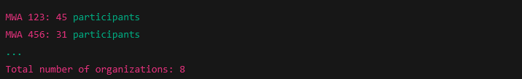
Specifically, the program counts participants by:
- Gender
- Race
- Responsible agency
Finally, it lists, in descending order, the 10 most numerous professions pursued by participants—along with the number of participants pursuing it.
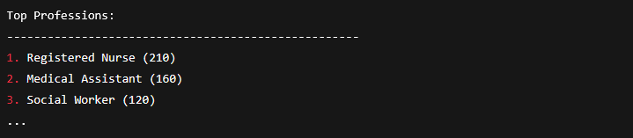

OUTCOMES
Per management comments, the program reduced analysis time for them when presenting to others.

